**Understanding ICO’s and the types of Tokens**

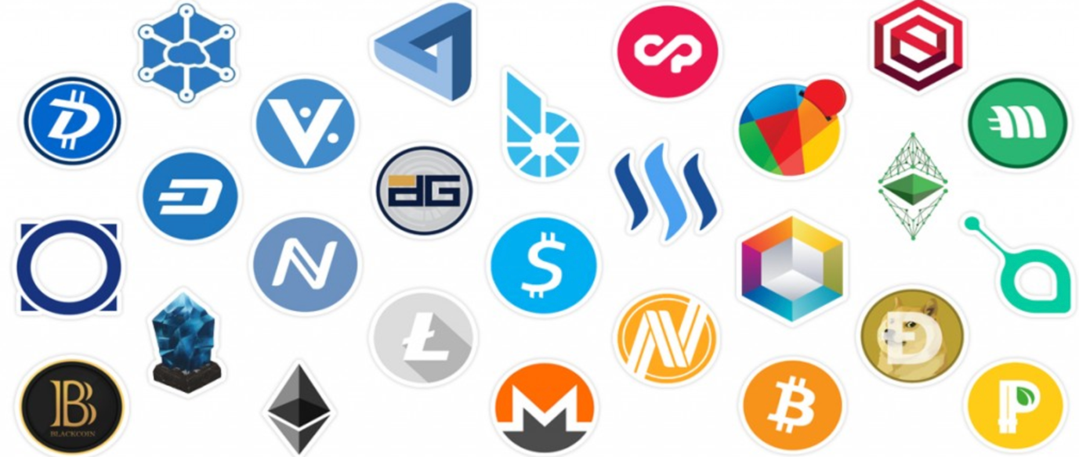

For decades one of the most established way of raising money was through the use of Venture Capitalists (VC’s), but something curious started to happen 18 months ago. Blockchain based projects started to raise revenue for projects through a new source called Initial Coin Offering (ICO).

Initial Coin Offering is the cryptocurrency equivalent of an Initial Public Offering (IPO) and are used to raise funds without the need of VC’s or banks. They are an innovative crowdfunding model allowing start-ups to bypass traditional early seed investments. They have proven to be wildly popular in the past year or so raising more than 3 billion dollars in just 2017 and even surpassing Venture Capital funding for internet companies.

How this works is that new businesses raise money by selling a “token” to early adopters and enthusiasts. But tokens are not to be confused with equity as they are not necessarily a share in the business or provide a dividend return to its buyers. Rather, by purchasing ICO tokens, holders can utilise and access the services and functionality the business’s network provides. Thus the value of token(s) lies in it’s scarcity and its ownership allowing participation in a decentralised network beneficial to its user.

However, the value of a token is not equal, in fact not all ICOs are created equal, there are at least four types of tokens.

|  |  |  |  |
| --- | --- | --- | --- |
| **Token Type** | **Function** | **Examples** |  |
| Currency Tokens | Designed to provide holder, right to purchase goods online |  |  |
| Utility Tokens | Provide access to a company’s product or service |  |
| Equity Tokens | Similar to stocks, represent a share in the company |  |  |
| Asset Tokens | They are claims on an underlying physical asset |  |  |

**Currency tokens**

This is the most prevalent and widely known token also known as cryptocurrency. They are digital tokens that can be used to buy and sell goods and can be held as a store of value and are simply a medium of value exchange. They are decentralised and operate independently of a central bank, using cryptography and a peer to peer network to ensure transaction security. Bitcoin is the most prominent examples of currency tokens.

**Utility tokens**

Also known as user tokens, provide access to a company’s platform, service or product. Utility tokens are not designed as investments but people purchase utility token ICO’s in the hope that the value of the tokens shall rise as demand for the company’s product increases. An example being Filecoin which raised a record $257 million to provide a decentralised cloud storage space that takes advantages of unused computer hard drive space.

**Equity tokens**

Equity tokens represent a share in a company that has completed a token sale. Thus equity tokens are in effect similar to stocks and imply ownership and control and are now deemed as a security, falling under the scope of global regulators. One of its most promising and growing applications It has been widely used by One of its earliest and most promising uses has been of Ethereum based smart contracts for start ups to issue “stock” through initial coin offerings. With Ethereum based DAO being the first major token Equity token with owners of DAO tokens having control over the running of the organisation.

Capital Coin is another player entering the market in 2018 that shall disrupt investment banking and change the landscape of fundraising. By introducing equity tokens to a broad array of industries and companies – that have no relation to Blockchain – Capital Coin will provide companies the convenience, ease and instant worldwide access to the global investor base that ICOs today enjoy. Capital Coin shall allow companies to conduct IPOs on a token platform but rather than giving tokens, enable companies to give equity/ shares. This is a game changer as a broad spectrum of companies considering fundraising could now use the newly invented and hugely successful method of ICOs. Thus bypassing traditional funding models such as VCs, IPO through investment banks in exchange issuing tokens representing shares directly to the public.

**Asset tokens**

They are digital tokens that represent a physical asset or product. Asset tokens are one of the largest areas of growth because they support real distributed, peer to peer ecosystems on the Blockchain. However, they may not be as popular amongst investors because the value of the tokens doesn’t usually exceed the value of the asset and thus has less upside potential than other types of tokens. These tokens are starting to gain traction with a start up project called Goldmint which is digitizing and tokenizing physical gold holdings, allowing investors to purchase difficult to store physical assets such as gold online.

Arifa Khan is a crypto pioneer who first conceptualised the idea of taking Blockchain to mainstream securities industry and elaborated this idea in a July 2017 white paper. She is behind this initiative of disrupting the Private Equity and Asset Management market and building Capital Coin. By creating a platform where investors and seekers of capital shall be able to interact and trade freely with minimum friction. Building a platform that shall enable businesses globally to raise funds for operations directly and in a more efficient manner whilst cutting the exorbitant fees associated with IPO’s and investment banks.